UNIT 3

Applications of the CNC Machines
- READING COMPREHENSION

Applications of the CNC Machines

written by: Haresh Khemani • edited by: Lamar Stonecypher • updated: 11/15/2009
This article describes the applications of the CNC machines in different industries.
- These days the CNC machines are found in almost all industries, from a small scale industry to big companies. There is hardly any facet of manufacturing that is not touched by the automated CNC machining center. Everyone involved in the manufacturing should know what a CNC machine can do for their company. Due to extensive applications of CNC machines in various industries, there is a great surge in the demand of the CNC programmers. To meet these demands a number of schools have come up that teach the operation and programming of the CNC machines.

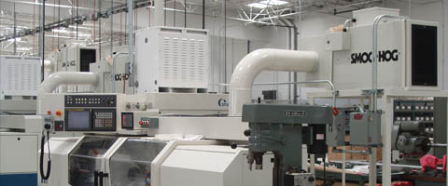

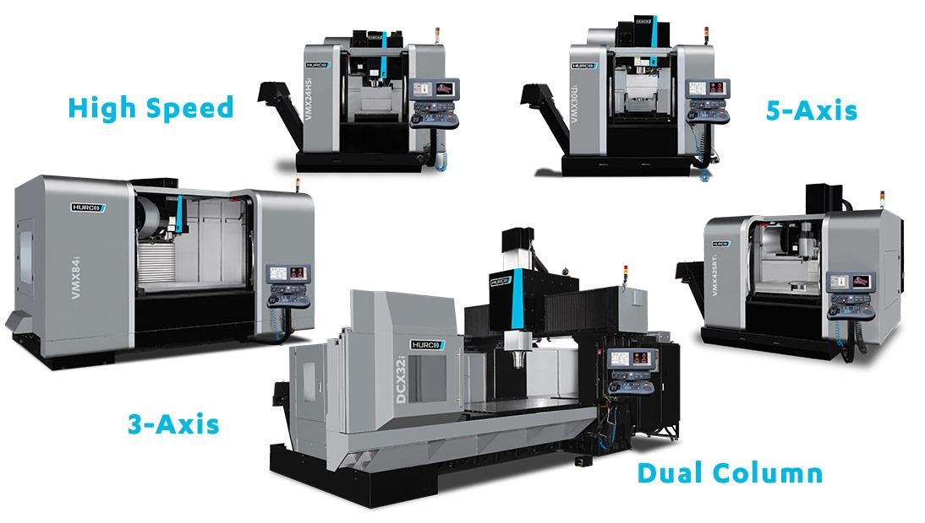

Some Industries where CNC Machining Centers are used
Here are some of the many industries where the CNC machining centers are used.
Industries for removing metal: The metal removing industries remove the metal from the raw material to give it the desired as per the requirements. These can be the automotive industries for making the shafts, gears, and many other parts. It can be manufacturing industries for making the various rounded, square, rectangular, threaded and other jobs. There are many other industries where the metal removal works are performed. All these metal removal works are performed by different machine tools like lathe, milling machine, drilling machine, boring machine, shaping machine, reamer, etc. Traditionally these machines are operated by the operators, but the CNC versions of all these machines are now used extensively. You can carryout almost all machining operations with the CNC machining centers. You can also carry out all the turning operations such as facing, boring, turning, grooving, knurling, and threading on your CNC turning centers. On your CNC grinders you can carry out the grinding of the internal diameter, outer diameter, and also the flat surfaces. The Contour Grinding technology enables you to grind surfaces of all shapes.

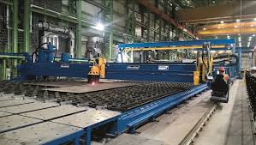

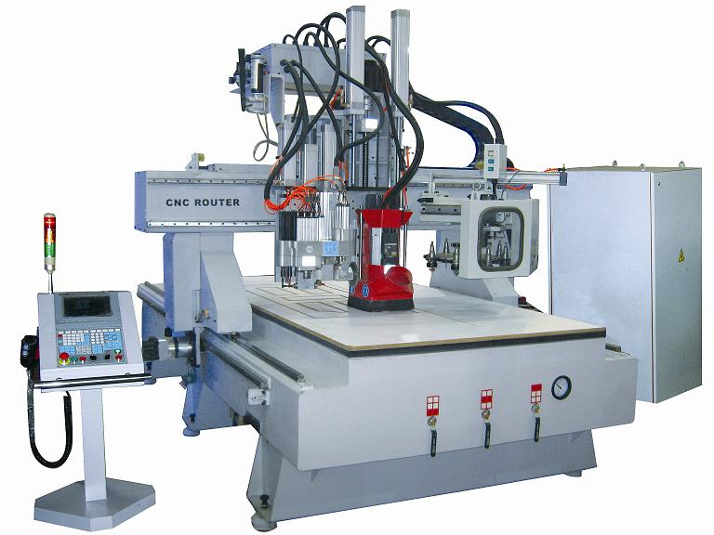

UNDERSTANDING THE PASSAGE
Task 1. Answer the following questions
  - What does this article describe?
…………………………………………………………………………………
…………………………………………………………………………………
  - Where are these days the CNC machines are found?
…………………………………………………………………………………
…………………………………………………………………………………
  - What should veryone involved in the manufacturing should know about ?
…………………………………………………………………………………
…………………………………………………………………………………
  - Why is there a great surge in the demand of the CNC programmers?
…………………………………………………………………………………
…………………………………………………………………………………
  - Do a number of schools teach the operation and programming of the CNC machines?
…………………………………………………………………………………
…………………………………………………………………………………

Exercise 3.Put a word to complete the passage

Applications, the plates, are used, machining operations, purposes
Industries for Fabricating Metals
In many industries thin plates like steel plates are required for various (1)……….., in fabrications industry the machining operations are performed on such plates. In these industries the CNC machines are used for various (2)…………….like shearing, flame or plasma cutting, punching, laser cutting, forming, and welding and many other (3)……….. To bring the plates to their final shape CNC lasers and CNC plasma cutters (4)………..commonly. To punch the holes in the plates of all sizes CNC turret punch presses are used.

VOCABULARY

describe (v) môtả
industry (n) côngnghiệp
scale industry(n) = industrial scale quymôsảnxuất
hardly (adv) hầunhưkhông
facet (n) khíacạnh, mặtphẳng
touch (v) chạm, tiếpxúc
automate (v) tựđộnghóa
automotive (a)
automated CNC machining center
involve in (v) gồm, baohàm
manufacturing (n) (sự) sảnxuất, (sự) chếtạo
extensive (a) rộnglớn, kéodàiraxa
surge (n) sựtràn, sự (dâng) nhưsống
programming (n) sựlậptrình
remove (v) di chuyển
removal (n) việc di chuyển
shaft(n) (kỹthuật) trục
gear (n) sựtruyềnđộngbánhrăng
thread (v) ren (đinhốc)
lathe (n,v) máytiện, tiện
boring machine (n) máykhoan
reamer (n) (kỹthuật) daokhoét, mũidao
version (n) kiểu (dạngđặcbiệthoặckhácnhauchútítcủacáigi )
facing (n) đốiphó, (xâydưng) ốpmặt
groove (n,v) đườngrãnh ( đụctrêntấmván, ….), xoirãnh
knurl (n) vânlăn, khía ( ở kimloại), chỗ u lên
grind(v, n) nghiền, sựnghiền
grinder (n) máyxay, ngướixay, thợmài
internal><outer ( a) bêntrong><phíangoài
diameter (n) đườngkình
surface (n) bềmặt
flat (n) mặtphẳng
enable (v) làmchocóthể (làmgì)

VOCABULARY

describe (v)
scale industry (n)
industry (n)
hardly (adv)
facet (n)
touch (v)
automated
automotive (a)
automated CNC machining center
involve in (v)
manufacturing
extensive (a)
surge (n)
programming (n)
remove (v)
metal removing industries
removal
metal removal work
shaft(n)
gear (n)
threaded
lathe (n)
boring machine (n)
reamer (n)
version (n)
facing
grooving
knurling
grind(v)
grinder
internal >< outer
diameter (n)
surface (n)
flat (n)
enable (v)
Exercise 3. Put a word to complete the passage
Industries for Fabricating Metals
In many industries thin plates like steel plates are required for various (1)……….., in fabrications industry the machining operations are performed on such plates. In these industries the CNC machines are used for various (2)…………….like shearing, flame or plasma cutting, punching, laser cutting, forming, and welding and many other (3)……….. To bring the plates to their final shape CNC lasers and CNC plasma cutters (4)……….. commonly. To punch the holes in the plates of all sizes CNC turret punch presses are used.

applications.; the plates; are used; machining operations; purposes;

